

Year 11 Human Biology

Cells and Tissues Test 2008

***Part A: Multiple Choice 20 marks***

1. During mitosis a chromosome is attached to the spindle by the;
   1. Centrosome
   2. Chromatid
   3. Centromere
   4. Centricle
2. The blue print for protein synthesis is carried to the site of the synthesis by?
   1. DNA
   2. Transfer RNA
   3. Messenger RNA
   4. ATP
3. Animal cells contain organelles. The organelle essential for normal cell division is;
   1. the mitochondria
   2. a Golgi body
   3. the nucleus
   4. the DNA
4. Mitochondria concentration will be the highest in which of these cells?
   1. Nerve cells
   2. Secretory cells
   3. Muscle cells
   4. Red blood cells
5. A series of interconnecting canals transporting fluids has been observed in the cell. These canals are called?
   1. Lysosomes
   2. Endoplasmic reticulum
   3. Centrioles
   4. Mitochondria
6. A group of cells similar in structure and function is a/an;
   1. organ
   2. tissue
   3. system
   4. organism
7. If a mixture of proteins and glucose is placed in a bag immersed in water, the glucose will diffuse through the bag but the protein will not. This is because the bag is:
   1. a living membrane
   2. selectively permeable
   3. permeable only to molecules of inorganic origins
   4. impermeable to all except large organic molecules
8. Colchicine is a chemical that inhibits the formation of spindles. This would affect a cell during:
   1. growth
   2. ageing
   3. cell division
   4. all of its normal functions
9. Which of the following combinations of lenses will give the greatest magnification in a microscope?
   1. x10 ocular lens x40 objective lens
   2. x5 ocular lens x10 objective lens
   3. x10 ocular lens x10 objective lens
   4. x5 ocular lens x5 objective lens
10. It is found that a specialised cell conducts impulses but performs no other function. Such a cell would best be classified as:
    1. a muscle cell
    2. a glandular cell
    3. an epithelial cell
    4. a nerve cell
11. How are ADP and ATP related?
    1. They are identical except ADP has more energy.
    2. ADP has one more phosphate group and less stored energy than ATP.
    3. They are opposite processes
    4. ATP has one more phosphate group and more stored energy than ADP
12. Which of the following is the main characteristic feature of epithelial tissue?
    1. Usually composed of large amounts of extra cellular material
    2. Blood vessels are located in this tissue
    3. Usually consists of multi-layers of cells
    4. One of its surfaces is usually exposed either to the exterior of the body or to the cavity of a hollow organ.
13. What do cells in the human body use as their primary source of energy?
    1. Amino acids
    2. Glucose
    3. Fatty acids
    4. Sucrose
14. Smooth muscle tissue:
    1. is in the walls of the arteries
    2. is attached to the skeleton
    3. contains many nuclei in each cell
    4. forms the wall of the heart
15. Mitotic division of a cell containing a diploid (2N) nucleus normally produces:
    1. 2 cells, each with a N nucleus
    2. 2 cells, each with a 2N nucleus
    3. 4 cells, each with a N nucleus
    4. 4 cells, each with a 2N nucleus
16. The organelles in the cell which are responsible respectively for protein synthesis, energy production and secretion are:
    1. ribosomes, Golgi bodies, endoplasmic reticulum
    2. Golgi bodies, ribosomes, mitochondria
    3. Ribosomes, mitochondria, Golgi bodies
    4. Mitochondria, ribosomes, endoplasmic reticulum
17. The type of tissue lining the digestive tract is:
    1. epithelial tissue
    2. connective tissue
    3. muscular tissue
    4. contractile tissue
18. The concentration of lactic acid in a muscle is found to be greater after exercise than before. The reason for this is:
    1. insufficient oxygen in the muscle
    2. an excess of carbon dioxide in the muscle
    3. insufficient glucose in the muscle
    4. a high rate of aerobic respiration
19. The energy in respiration is utilised for many processes. One process not requiring energy is:
    1. active transport
    2. protein synthesis
    3. muscle contraction
    4. combination of oxygen and haemoglobin
20. Which of the following statements about caner is incorrect?
    1. Viruses can cause cancer
    2. Our immune system protects us against cancer
    3. The incident of cancer in developed countries is decreasing
    4. Leukaemia is a cancer of tissue that forms blood cells

***Part B: Short Answers 40 marks***

***Name: _______________________________________***

**QUESTION 1** (Total 8 marks)

The diagram below refers to Question 1.

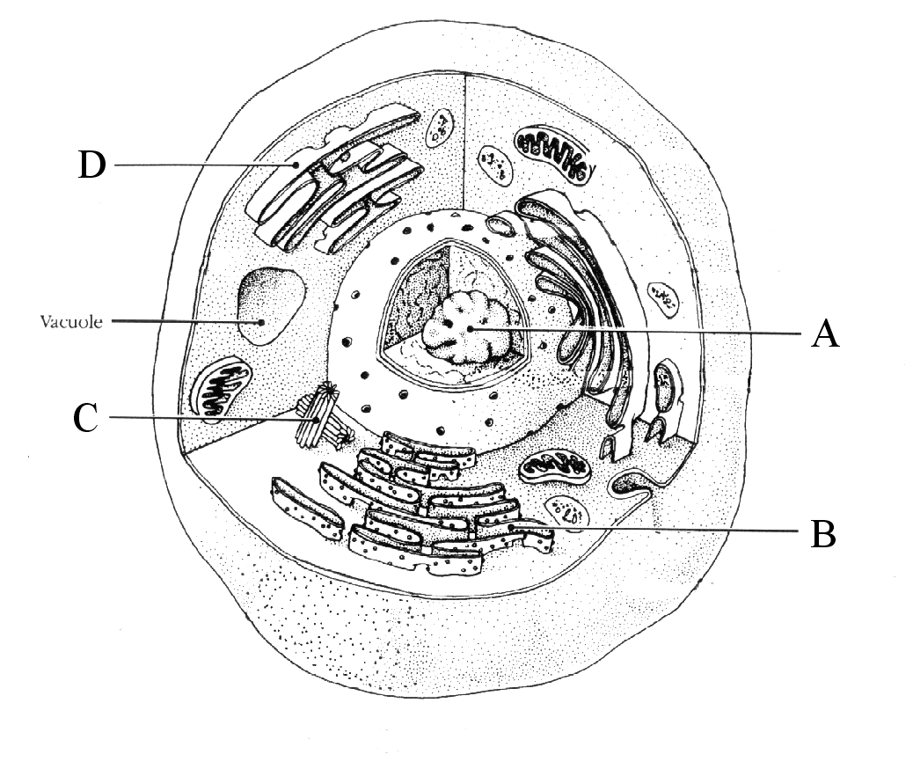

|  |  |
| --- | --- |
| **Structure** | **Function** |
| **A.** |  |
| **B.** |  |
| **C.** |  |
| **D.** |  |

**QUESTION 2** (Total 10 marks)

The diagrams below show various stages of mitosis, they are in a jumbled order.

a) Underneath each diagram write the correct name of the phase.

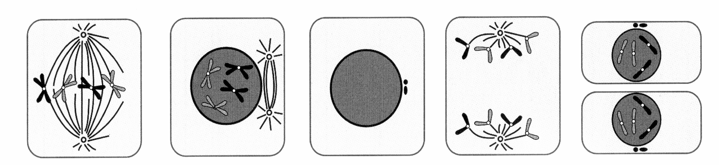

…………………. ……………… ……………… ………………. ………………

(5)

b) Complete the below table by placing the phases in order and explaining the

major events of each.

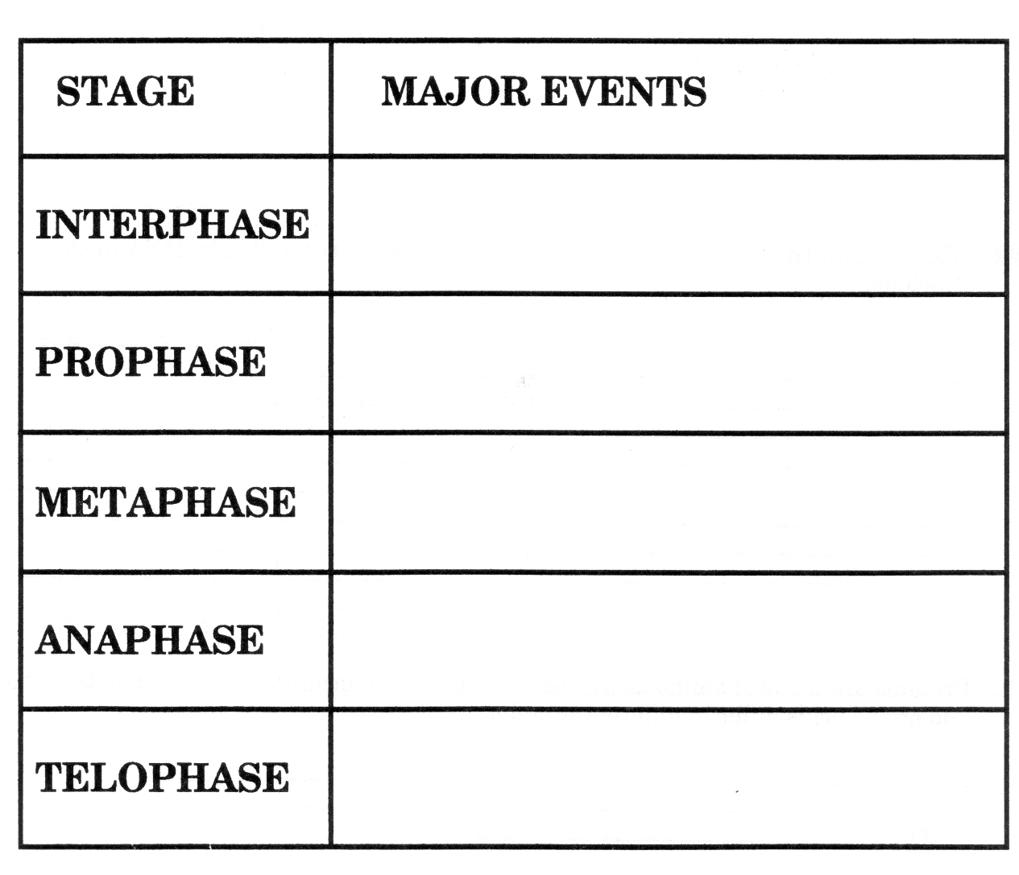

(5)

**QUESTION 3** (Total 6 marks)

|  |  |  |
| --- | --- | --- |
| **Tissue Drawing** | **Type of Tissue** | **Where in the body is this tissue found?** |
|  |  |  |
|  |  |  |
|  |  |  |

**QUESTION 4** (Total 9 marks)

Cellular respiration is the process of oxidising _____________, to form ________________ and ___________ . Energy released is trapped in the form of __________________ ________ ________________for use by all the energy-consuming activities of the cell. The process occurs in two phases.

Complete the following table.

|  |  |  |  |  |
| --- | --- | --- | --- | --- |
| Process | Where it occurs | What is required | Waste product(s) | Number of ATP produced |
|  |  |  |  |  |
|  |  |  |  |  |

**QUESTION 5** (Total 7 marks)

Explain how the synthesis of proteins by ribosomes is controlled by DNA in the nucleus.

______________________________________________________________________________________________________________________________________________________________________________________________________________________________________________________________________________________________________